OBE Screens:

This is the basic screen format to understand how the quiz will look like.. Below screenshots are some notes, points, suggestions and questions

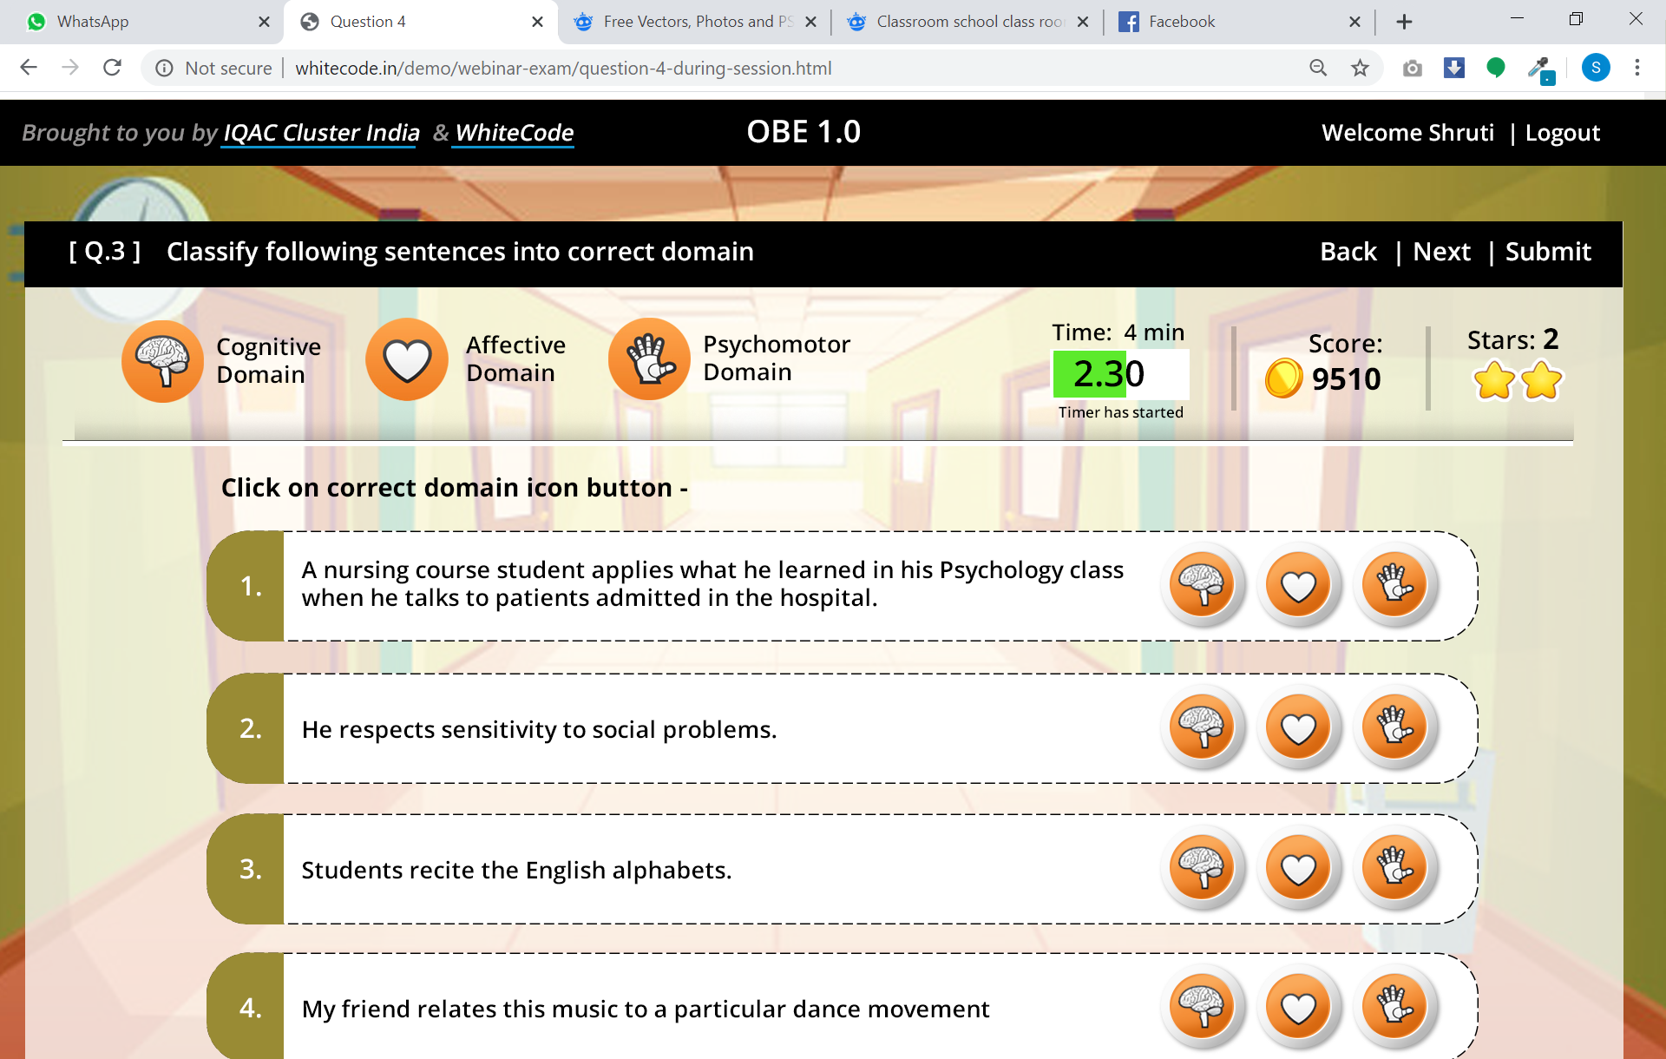

* The screen shows basic layout of the quiz/game..
* **Logos:** The logos of cluster and whitecode have not been shown, so that maximum space can be utilized for the quiz. However the logos will be shown on hover of the company names. Example for that has been at the end of the document.
* **Logout:** User will be given logout option for the screen. If he logs out without submitting all the answer.   
  *To be discussed and decided:*
  + What will happen – will the answers get saved? Will he able to see the answers next time he visits the screens
* **Time and Timer:** User needs to answer the question / perform the task withing time given to him.

*To be discussed and decided:*

* + When will the timer start? On the load of screen? What will happen when time is up?
* **Score:** We can give some score (10 or 20) per question, so that user will feel motivated to play further.
* **Stars:** We can think of giving stars to the users if he gives all the answers correctly.. or if he gives answers very fast.
* **Question area:** Here will be different questions for the user.

**Mouse-Hover examples (on company names)**

When user mouse-hovers the company name, a fancy tooltip is shown to the user giving brief information about company. On click of the company name, user can visit the site of the company.

Example 1:

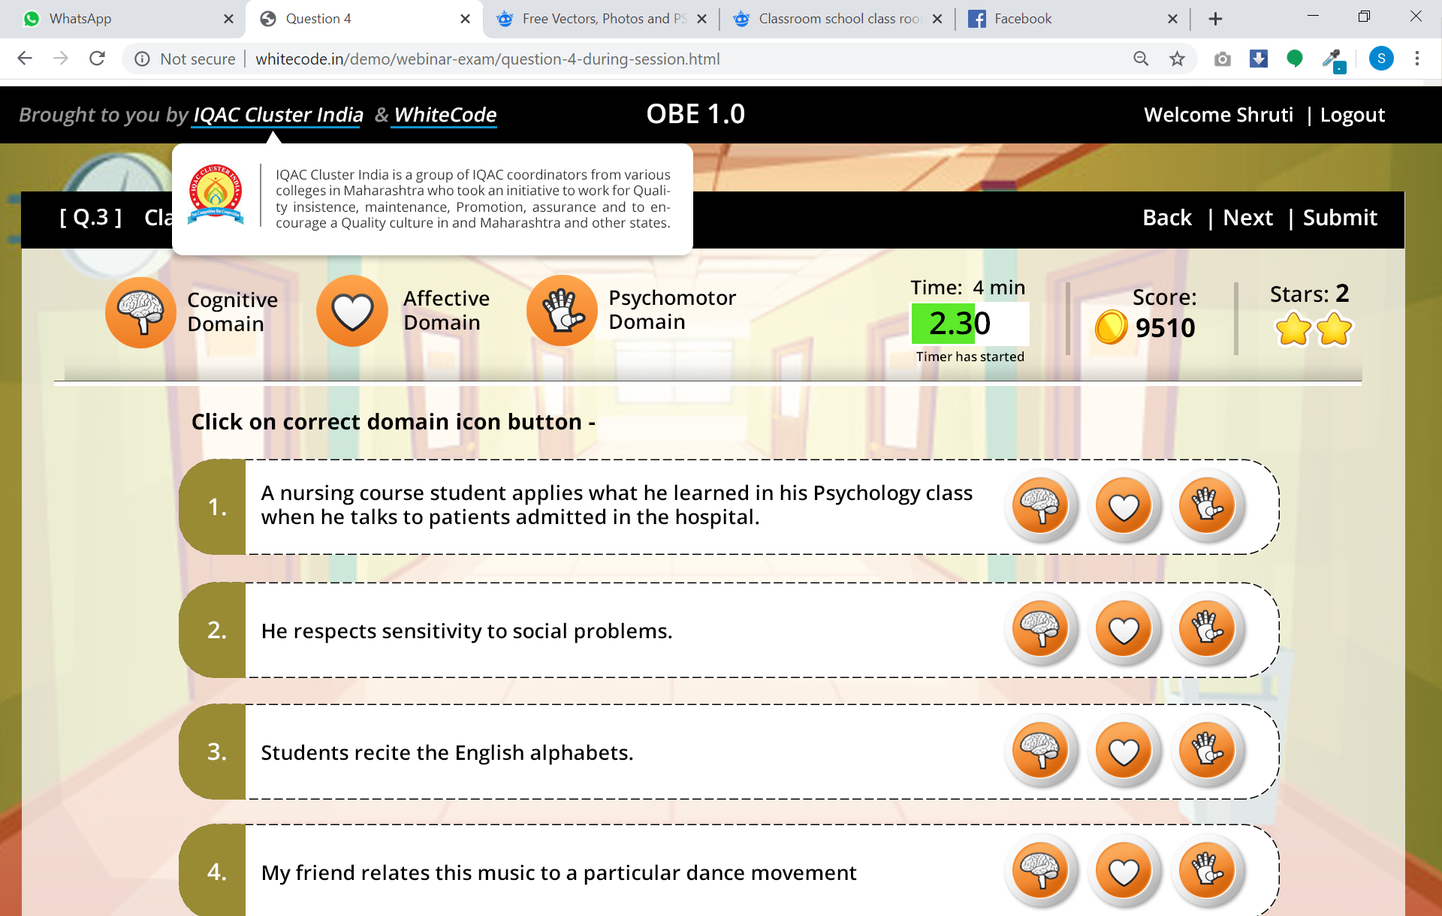

Example 2:

